**Kubernetes Task**

**Task Description:**

Setup minikube at your local and explore creating namespaces (Go through official documentation).

Steps:

1. Install docker, minikube, kubectl

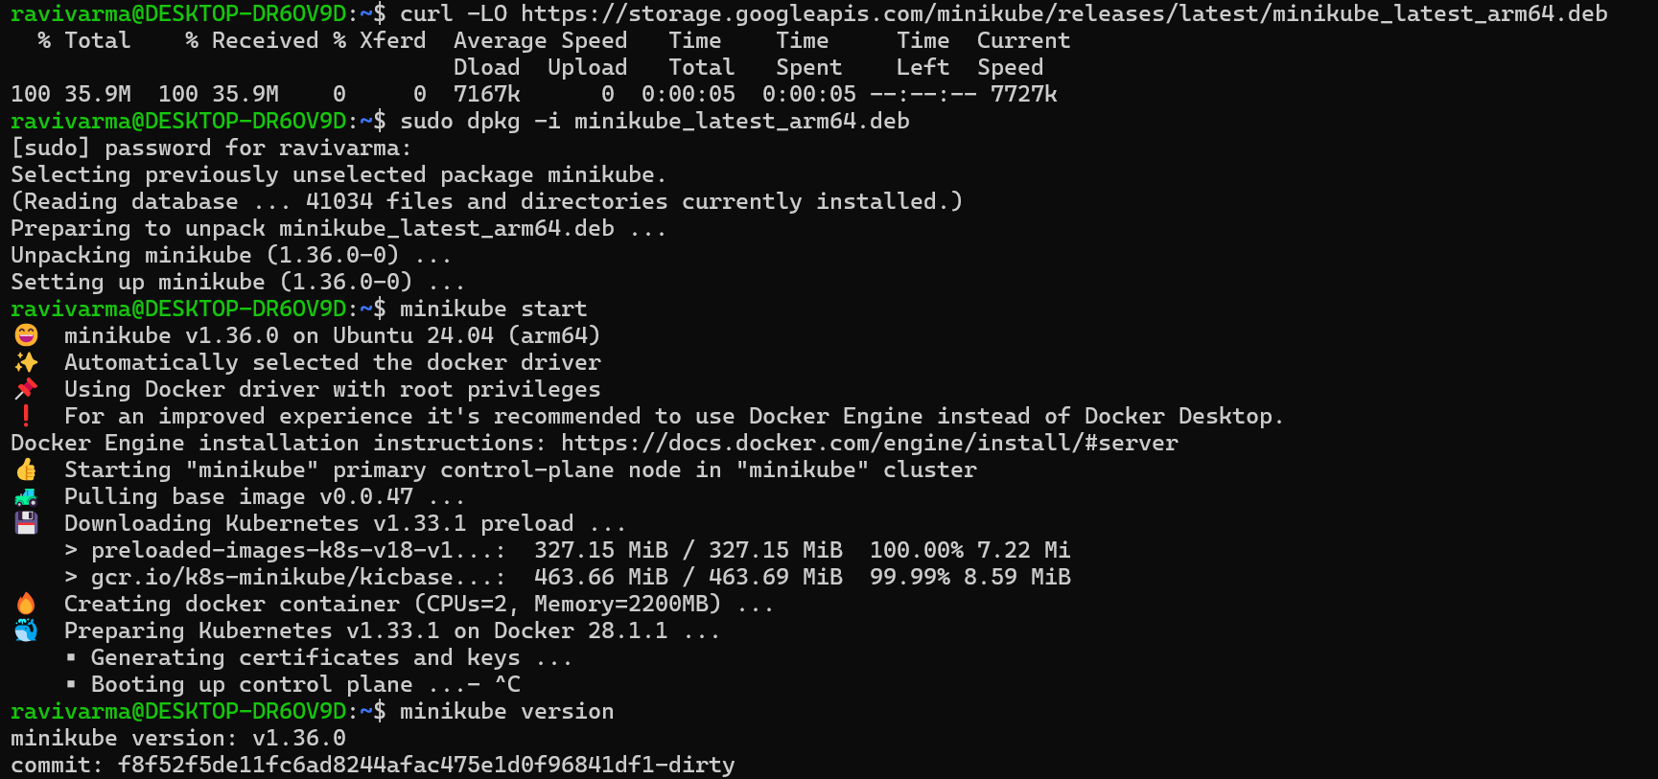

1. Start minikube

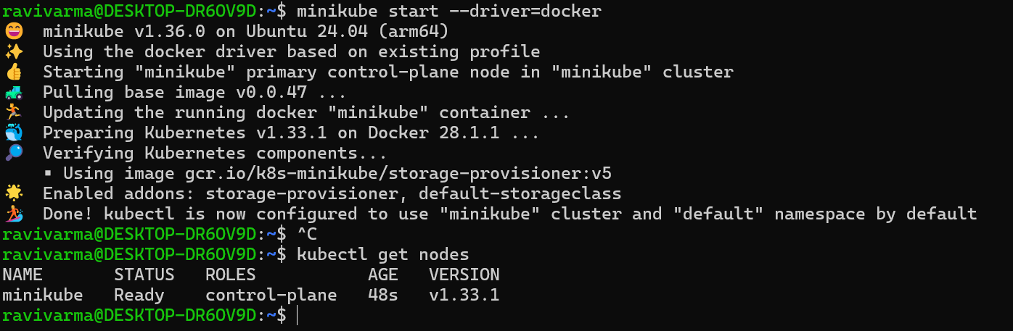

1. Create new namespaces and run pods in them

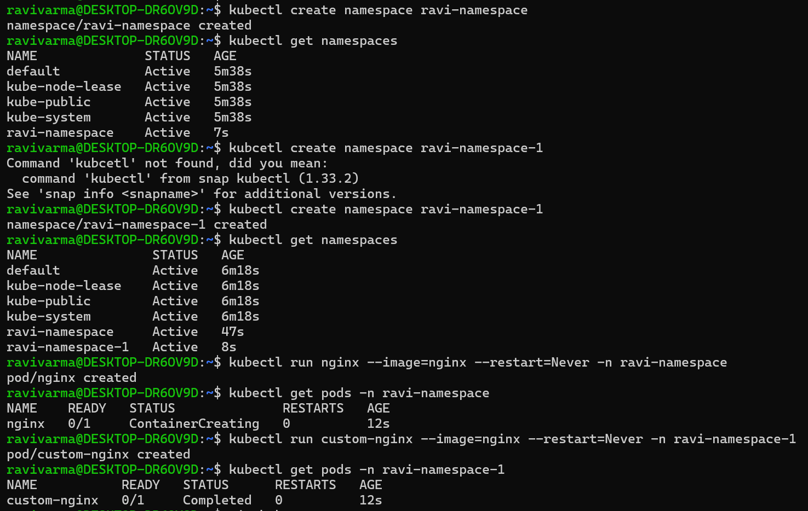

1. Stop and delete the minikube

